24/25 MECH3465 Robotics and Machine Intelligence

 | School of Mechanical Engineering  MECH3465 - Robotics and Machine Intelligence

Mark
Assignment:

Coursework 1: Aircraft Recognition CNN

Name | Student ID | Signature
Louie Burns | 201588498
Dan Nehushtan | 201594650

Dan Instructions:
Hi Dan, please could you add the following:
- Add some data analysis and some comments to section 2
e.g. Max Accuracies for test/training, shape of graphs, where training tapers off, loss for training/testing…….
(SECTION 2)

- Finish and add comments to the evaluation section
(SECTION 3)

- Edit the baseline and improved model juypter notebooks so that they look neat instead of one big blob

Thanks Pookie,
Love Louie

Section 1: Mode and Optimisation
A detailed rational for the choice of your mode and optimisation processes of fine tuning your model (max 200 words).
Convolutional Neural Networks (CNNs) are ideal for image classification as they are specifically designed to process images through convolutional operations. They automatically learn hierarchical features directly from raw image data, making them highly adaptable and scalable for complex datasets.
A key aim was to improve the F1 score, which depends on the accuracy of training and test data; thus, prioritising accuracy enhancements was essential. The Simple CNN architecture was improved by increasing image resolution and adding layers. These changes enable the model to capture finer details and extract higher-order features, essential for accurate classification. Batch normalisation stabilises training by normalising inputs to each layer, accelerating convergence, and reducing sensitivity to weight initialisation. A dynamic learning rate schedule, halving every five epochs, ensures steady convergence by preventing oscillations near minima and balancing exploration and refinement.
Increasing the number of epochs provided more opportunities for the model to learn data patterns, while data augmentations (horizontal flips, random rotations, and normalisation) improved generalisation by simulating real-world variations and mitigating overfitting risks. Selecting the categories with the highest image counts ensured balanced class representation, maximising training data and improving performance.
These changes collectively contributed to improving the F1 score and the model’s accuracy/ performance.

Section 2: Improved Model Comparison
A section comparing your model to your optimised model, accompanied by evaluation metrics in the form of tables or graphs and draw conclusions (max 200 words).

The improved model includes these changes:
- Increased image quality from 64x64 to 128x128
- Increased epochs from 15 to 40
- Dynamic Learning Rate (halves every 9 epochs) instead of fixed rate
- Multiple Neural Network Layers added
- Added Batch Normalisation
- Chooses the categories based on the highest number of images, increasing the amount of training data (although this could lead to overfitting)
- Additional pre-processing including horizontal flip, random rotation and normalisation

Training & Test Loss:
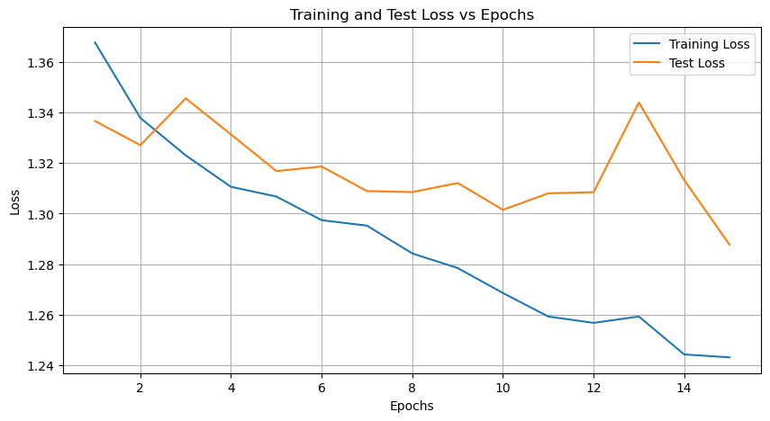
Figure 1: Training and Test Loss vs Epoch for the simple model
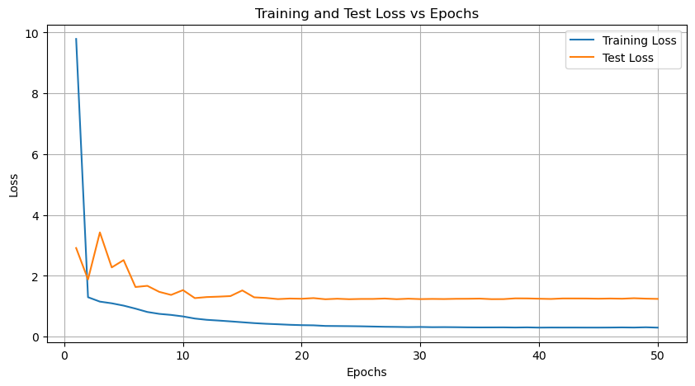
Figure 2: Training and Test Loss vs Epoch for the improved model

Training & Test Accuracy:

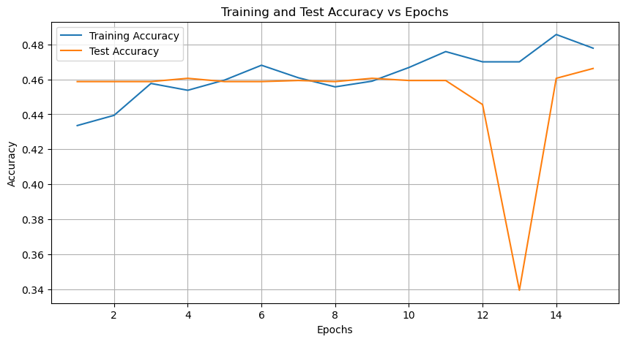
Figure 3: Training and Test Accuracy vs Epoch for the simple model
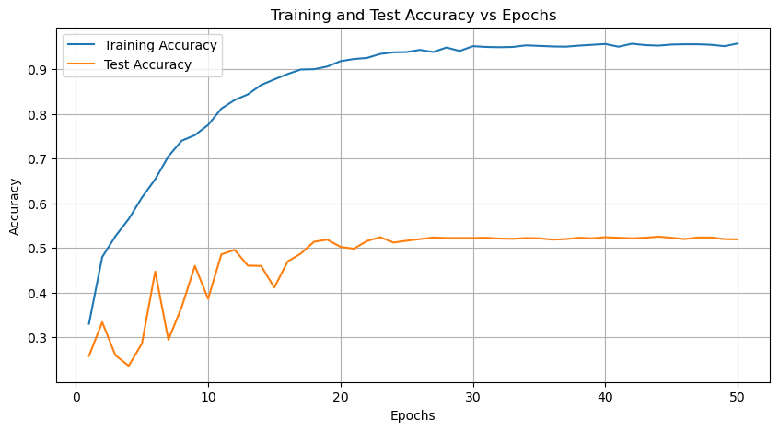
Figure 4: Training and Test Accuracy vs Epoch for the improved model

F1 Score:
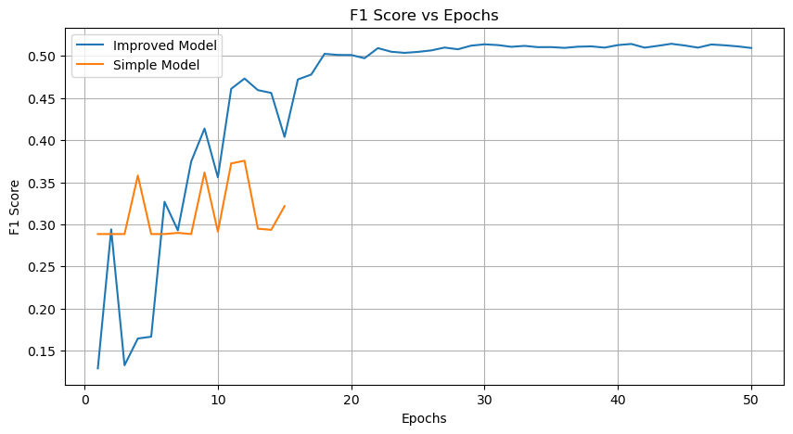
Figure 5: F1 Score vs Epoch for the simple and complex model
Learning Rate Values:
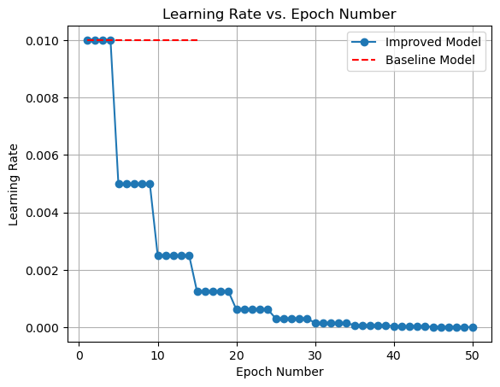
Figure 7: The learning rate per epoch for the simple and improved CNN models

Simplified Model Results:

Epoch | Train Loss | Test Loss | Train Acc | Test Acc | F1 Score
1/15 | 1.3676 | 1.3366 | 0.4336 | 0.4587 | 0.2885
2/15 | 1.3378 | 1.3270 | 0.4395 | 0.4587 | 0.2885
3/15 | 1.3230 | 1.3455 | 0.4577 | 0.4587 | 0.2885
4/15 | 1.3106 | 1.3313 | 0.4538 | 0.4606 | 0.3580
5/15 | 1.3067 | 1.3168 | 0.4596 | 0.4587 | 0.2885
6/15 | 1.2974 | 1.3186 | 0.4681 | 0.4587 | 0.2885
7/15 | 1.2953 | 1.3089 | 0.4609 | 0.4594 | 0.2899
8/15 | 1.2843 | 1.3085 | 0.4557 | 0.4587 | 0.2885
9/15 | 1.2785 | 1.3121 | 0.4590 | 0.4606 | 0.3616
10/15 | 1.2687 | 1.3015 | 0.4668 | 0.4594 | 0.2914
11/15 | 1.2593 | 1.3080 | 0.4759 | 0.4594 | 0.3724
12/15 | 1.2568 | 1.3085 | 0.4701 | 0.4456 | 0.3756
13/15 | 1.2594 | 1.3439 | 0.4701 | 0.3394 | 0.2949
14/15 | 1.2444 | 1.3132 | 0.4857 | 0.4606 | 0.2935
15/15 | 1.2432 | 1.2877 | 0.4779 | 0.4662 | 0.3217
Table 1: The results of each epoch calculation for the simplified CNN model
The learning rate for this model was kept constant at 0.01

Improved Model Results:

Epoch | Train Loss | Test Loss | Train Acc | Test Acc | F1 Score | Learning Rate
1 | 9.7901 | 2.916 | 0.3305 | 0.2585 | 0.1291 | 0.01
2 | 1.2984 | 1.8835 | 0.4799 | 0.3341 | 0.2941 | 0.01
3 | 1.1537 | 3.4296 | 0.5267 | 0.2597 | 0.1328 | 0.01
4 | 1.0983 | 2.2783 | 0.5651 | 0.2364 | 0.1645 | 0.01
5 | 1.022 | 2.5181 | 0.6131 | 0.2861 | 0.1667 | 0.005
6 | 0.9227 | 1.6339 | 0.6539 | 0.4475 | 0.3269 | 0.005
7 | 0.8128 | 1.6726 | 0.7055 | 0.2945 | 0.2929 | 0.005
8 | 0.7509 | 1.4749 | 0.7403 | 0.3677 | 0.3747 | 0.005
9 | 0.7161 | 1.3737 | 0.7528 | 0.4601 | 0.4138 | 0.005
10 | 0.6666 | 1.5316 | 0.7756 | 0.3863 | 0.3559 | 0.0025
11 | 0.5969 | 1.2691 | 0.8122 | 0.4859 | 0.461 | 0.0025
12 | 0.5553 | 1.3032 | 0.8314 | 0.4961 | 0.4732 | 0.0025
13 | 0.5309 | 1.317 | 0.844 | 0.4607 | 0.4594 | 0.0025
14 | 0.5038 | 1.3353 | 0.865 | 0.4601 | 0.4561 | 0.0025
15 | 0.475 | 1.5218 | 0.8776 | 0.4115 | 0.4038 | 0.00125
16 | 0.4468 | 1.2946 | 0.8896 | 0.4697 | 0.472 | 0.00125
17 | 0.4251 | 1.274 | 0.8998 | 0.4877 | 0.4779 | 0.00125
18 | 0.4094 | 1.2364 | 0.9004 | 0.5141 | 0.5025 | 0.00125
19 | 0.3914 | 1.2547 | 0.9064 | 0.5189 | 0.5012 | 0.00125
20 | 0.3799 | 1.2475 | 0.9184 | 0.5027 | 0.5011 | 0.000625
21 | 0.374 | 1.269 | 0.9232 | 0.4985 | 0.4973 | 0.000625
22 | 0.3537 | 1.2318 | 0.9256 | 0.5159 | 0.5093 | 0.000625
23 | 0.3503 | 1.2485 | 0.9346 | 0.5243 | 0.505 | 0.000625
24 | 0.3466 | 1.233 | 0.9382 | 0.5123 | 0.5037 | 0.000625
25 | 0.3416 | 1.2415 | 0.9388 | 0.5165 | 0.5048 | 0.0003125
26 | 0.3338 | 1.2418 | 0.9436 | 0.5201 | 0.5065 | 0.0003125
27 | 0.3262 | 1.2549 | 0.9388 | 0.5237 | 0.5099 | 0.0003125
28 | 0.322 | 1.2335 | 0.949 | 0.5225 | 0.5079 | 0.0003125
29 | 0.3158 | 1.2496 | 0.9412 | 0.5225 | 0.5122 | 0.0003125
30 | 0.3202 | 1.2363 | 0.952 | 0.5225 | 0.5138 | 0.00015625
31 | 0.3131 | 1.2424 | 0.9502 | 0.5231 | 0.5128 | 0.00015625
32 | 0.3151 | 1.2382 | 0.9496 | 0.5213 | 0.5108 | 0.00015625
33 | 0.3121 | 1.2461 | 0.9502 | 0.5207 | 0.5119 | 0.00015625
34 | 0.3073 | 1.2474 | 0.9538 | 0.5225 | 0.5104 | 0.00015625
35 | 0.3053 | 1.2525 | 0.9526 | 0.5219 | 0.5105 | 7.81E-05
36 | 0.3059 | 1.2345 | 0.9514 | 0.5189 | 0.5095 | 7.81E-05
37 | 0.3071 | 1.2359 | 0.9508 | 0.5201 | 0.5109 | 7.81E-05
38 | 0.3021 | 1.2605 | 0.9532 | 0.5231 | 0.5113 | 7.81E-05
39 | 0.307 | 1.2585 | 0.955 | 0.5219 | 0.5098 | 7.81E-05
40 | 0.2991 | 1.2489 | 0.9568 | 0.5243 | 0.5129 | 3.91E-05
41 | 0.302 | 1.2407 | 0.9508 | 0.5231 | 0.5142 | 3.91E-05
42 | 0.3011 | 1.2574 | 0.9574 | 0.5219 | 0.5098 | 3.91E-05
43 | 0.3013 | 1.257 | 0.9544 | 0.5231 | 0.512 | 3.91E-05
44 | 0.3002 | 1.2557 | 0.9532 | 0.5255 | 0.5144 | 3.91E-05
45 | 0.2998 | 1.249 | 0.9556 | 0.5231 | 0.5124 | 1.95E-05
46 | 0.3018 | 1.2555 | 0.9562 | 0.5201 | 0.5098 | 1.95E-05
47 | 0.3055 | 1.249 | 0.9562 | 0.5237 | 0.5136 | 1.95E-05
48 | 0.3013 | 1.2653 | 0.955 | 0.5237 | 0.5126 | 1.95E-05
49 | 0.3102 | 1.2511 | 0.952 | 0.5201 | 0.5113 | 1.95E-05
50 | 0.2984 | 1.2431 | 0.958 | 0.5195 | 0.5094 | 9.77E-06
Table 2: The results of each epoch calculation for the improved CNN model

Section 3: Evaluation
A critical evaluation and reflection on the results, discussing potential improvements and acknowledging any limitations of your approach (max 200 words).

Batch size had to be decreased to make the model work
Much longer compute time
No further improvements when these changes are made:
- Increase image quality even more to 512x512
- Adding more epochs
- Adding colour jitter to pre-processing
- Early dropout

Limitations due to low number of training data
Long compute time due to local computing power
Using additional pre trained models or additional external training data sets could help improve accuracy
Section 4: Ethics
A statement on ethical and societal implications of the booming usage of artificial neural networks in engineering (max 200 words).
A significant issue for artificial neural networks (ANN) is bias and fairness, as ANNs heavily rely on training data. If the data is biased, models risk perpetuating societal inequalities, particularly in engineering applications like resource allocation or urban planning, where outcomes can disproportionately affect certain groups.
Additionally, the lack of transparency and explainability in ANNs poses challenges in safety-critical fields like healthcare and aerospace engineering, where accountability and trust are essential. Data and privacy concerns are also paramount, as ANNs often require vast amounts of sensitive data, raising risks of misuse, inadequate data protection, and breaches that could have far-reaching consequences.
The environmental impact of training large-scale ANNs is another concern, as their computational demands significantly contribute to carbon emissions, highlighting the need for energy-efficient approaches. Furthermore, job displacement caused by automation driven by ANNs raises societal concerns, particularly in industries reliant on repetitive tasks, necessitating reskilling initiatives to minimise unemployment.
Misuse and security risks also emerge as ANNs can be exploited for malicious purposes, such as cybersecurity attacks or infrastructure vulnerabilities. To address these concerns, it is vital to develop ethical, sustainable, and inclusive AI systems that prioritise fairness, transparency, privacy, and equitable access while mitigating risks.

Baseline Model and Simple Model are used interchangeably. They both relate to the model without any improvements added

